White Paper

The Future of Biofuels in Renewable Energy and Reduction of Global Warming

to obtain a complete copy, please email request to Dr. Brown below


Professor R. Malcolm Brown, Jr.
Dr. David R. Nobles, Jr.

Section of Molecular Genetics and Microbiology
The University of Texas at Austin
Austin, Texas 78712

Contacts:
rmbrown@mail.utexas.edu

URL: www.botany.utexas.edu

Version 4K
April 28, 2008

Introduction

The cyanobacteria are an incredible group of microbes that capture CO₂ through photosynthesis, fix nitrogen from the atmosphere, and grow in fresh or saline water. The captured CO₂ is converted into sugars, polysaccharides, and biomass which can be utilized for the production of specialty products, ethanol and other biofuels. The ability of these organisms to fix nitrogen eliminates the need for the expensive and environmentally unfriendly petroleum-based nitrate fertilizers required for traditional crops. Additionally, growth in saline water greatly reduces the use of our shrinking and increasingly valuable fresh water supplies. Although the cyanobacteria use a photosynthetic process that is remarkably similar to that of plants and algae, they are much simpler organisms. Because of their simplicity, they utilize sunlight and nutrients more efficiently than land-based crops and they can be genetically manipulated with relative ease.

We have pioneered methods to convert cyanobacteria into photosynthetic feedstock producing factories. Through the manipulation of growth conditions and genetic modifications, our cyanobacteria have been engineered for the efficient production of sucrose, glucose, and cellulose. These biofuel feedstock components are secreted into the liquid environment that the cells are grown in and can be removed for processing without harvesting or harming the cells. Therefore, our photosynthetic factories can continue to produce product uninterrupted by feedstock harvests – unlike plants and algae, which are destroyed at each harvest and must be regenerated for each subsequent harvest.

As an example, the chart below shows U. S. production levels of ethanol (gallons) per acre for corn and raw sugar from sugar cane compared with predicted production levels for cyanobacterial sucrose from our strains.

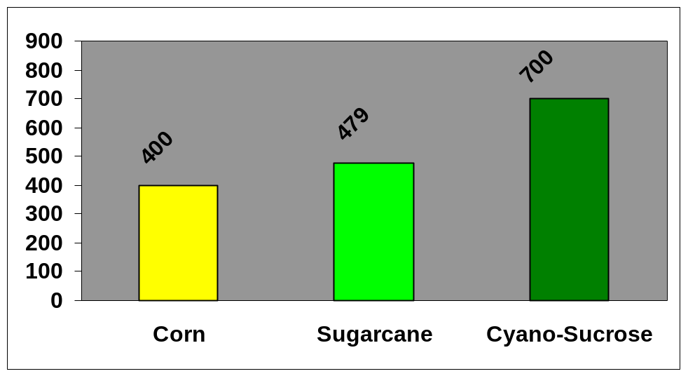

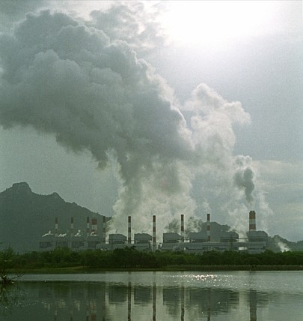

In summary, cyanobacteria can reduce major greenhouse gas emissions on a gigantic scale and convert CO₂ into productive biomass utilizing non-arable lands. Therefore, they offer a unique solution to one of the greatest problems facing humankind. The global warming crisis will not be solved by one method or procedure alone. Rather, many innovative solutions will be required to resolve this serious problem. However, developing the products of photosynthesis will certainly play a major role in any biological solution to the problem.

Scaling up of photobioreactor areas to thousands of square miles will not be an easy task. Massive engineering resources and creativity will be required to design and build such facilities. The capital costs for the photobioreactors must be low so that the unit costs to make and sell the products is competitive. With the ingenuity that has demonstrated itself over and over again in the United States, we feel confident that scaleup will someday be a reality, and our dreams for helping to resolve a number of environmental and political crises will have been worth the effort.

A very large-scale project (such as the Apollo mission to the moon or the atomic bomb Manhattan project) to bring together the creative genius of scientists, engineers, financiers, politicians, and citizens appears to be necessary to tackle the extremely complicated interactions required for effective resolution. It can be done! Our effort is to bring this new approach to the attention of those who can make things work.

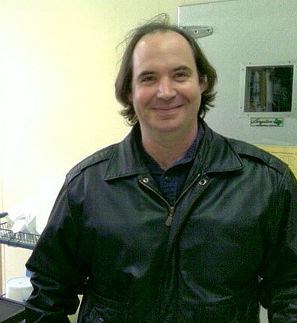
R. Malcolm Brown, Jr. David R. Nobles, Jr.

Version 4J
April 23, 2008

